PROJECT REPORT
FOR
Foundations of Artificial Intelligence
AI SKIN CARE EXPERT SYSTEM WITH DYNAMIC SKIN DIGITAL TWIN
A PROJECT REPORT
Submitted by
240701012 – ABISHAA R
240701047 – ARIFA H

October, 2026
BONAFIDE CERTIFICATE
Certified that this project report “AI SKIN CARE EXPERT SYSTEM WITH DYNAMIC SKIN DIGITAL TWIN” is the bonafide work of “ABISHAA R (240701012) and ARIFA H (240701047)” who carried out the project work under my supervision.
SIGNATURE OF THE FACULTY INCHARGE
Submitted for the Practical Examination held on ________________
SIGNATURE OF THE INTERNAL EXAMINER
TABLE OF CONTENTS
CHAPTER NO. AND TITLE PAGE NO.
ABSTRACT 1
1. INTRODUCTION 2
2. LITERATURE REVIEW 4
3. PROPOSED SYSTEM 6
3.1 OVERVIEW OF THE PROPOSED SYSTEM 6
3.2 ARCHITECTURE DIAGRAM 6
3.3 WORKING METHODOLOGY 7
3.4 ALGORITHMS AND TECHNIQUES USED 7
3.5 USER INTERFACE DESIGN 8
3.6 SECURITY AND PRIVACY 9

4. MODULES DESCRIPTION 10
4.1 USER AUTHENTICATION 10
4.2 INTERACTIVE SKIN ANALYSIS 10
4.3 SKIN CARE REPORT GENERATION 11
4.4 SKIN DITAL TWIN AND HISTORY 12
4.5 GRAPHICAL INSIGHTS 12
4.6 DAILY SKIN CARE ROUTINE 12
4.7 THEME AND INTERFACE MANAGEMENT 13
5. IMPLEMENTATION AND RESULTS 14
5.1 EXPERIMENTAL SETUP 14
5.2 USER INTERFACE IMPLEMENTATION 14
5.3 WEBCAM AND SKIN ANALYSIS IMPLEMENTATION 15
5.4 GRAPHICAL INSIGHT IMPLEMENTATION 15
5.5 AUTHENTICATION AND PASSOWRD RECOVERY 16
5.6 RESULT AND DISSCUSSION 16

6. CONCLUSION AND FUTURE WORK 17
7. REFERENCES 18
ABSTRACT
The AI Skin Care Expert System with Dynamic Skin Digital Twin is a web-based application designed to provide simple and understandable skincare guidance. The system combines traditional computer vision, user-provided information, and a rule-based expert system to generate general skincare suggestions without using machine learning, deep learning, or external artificial intelligence APIs.
The application allows users to create an account, log in securely, capture a face image through a webcam, and answer a few questions about their skincare concerns. The system checks the quality of the captured image and processes supported visual information. The resulting report presents photo quality, relevant observations, the user's answers, and general skincare suggestions in a neat and organised format. The application also includes a Dynamic Skin Digital Twin that maintains a history of saved assessments and daily skincare activities. Bar and line graphs help users understand recorded image-quality measurements and changes in assessment history. Additional features include a light and dark theme, a daily skincare checklist, report downloads, and email-based password recovery. The primary objective is to make skincare guidance accessible through a professional and interactive interface. The system is intended for general skincare education and does not diagnose medical conditions or replace professional medical advice.

1. INTRODUCTION
Skincare is an important part of personal care. However, users may find it difficult to understand different skincare recommendations and maintain a consistent routine. Information available online may contain technical terms, conflicting suggestions, and unnecessary details.
Artificial Intelligence offers a natural way to include these practical factors.
The proposed AI Skin Care Expert System provides a simple web application where users can capture a face image, answer basic questions, and receive general skincare guidance. The application focuses on a clean interface, understandable reports, and interactive features that help users navigate the system easily.

PROBLEM STATEMENT
Many skincare applications present complicated results, rely on automated predictions that users cannot easily understand, or fail to provide a convenient way to maintain assessment history. Users may also experience difficulties with complicated interfaces, unclear reports, and inconsistent skincare routines. Furthermore, a webcam image alone cannot reliably determine many important skin characteristics. Therefore, a simple and transparent skincare guidance system is required to combine basic image-quality checks, user-reported concerns, rule-based suggestions, and historical records in a single application.

OBJECTIVES
- To develop a professional, user-friendly skincare web application with secure registration, login, logout, and password recovery.
- To capture facial images through a webcam and perform face detection with basic image-quality checks.
- To generate organised skincare assessment reports and provide general skincare suggestions using predefined logical rules.
- To display bar and line graphs using recorded data and maintain user-specific assessment history and daily skincare routines.
- To provide light and dark themes while protecting user accounts and private records, without using machine learning, deep learning, or external AI APIs.

SCOPE

The project focuses on image processing, rule-based skincare guidance, and user account management. It supports webcam image capture, photo-quality checks, and user questionnaires. The system generates organised skincare assessment reports and general suggestions. It provides assessment history, daily routine tracking, and graphical summaries. The application is designed for general skincare education and awareness. It does not diagnose skin diseases, prescribe medicines, or measure actual skin conditions using a webcam.

ORGANISATION OF THE REPORT
The report consists of seven chapters covering the introduction, literature review, proposed system, modules, implementation and testing, conclusion and future enhancements, and references.

2. LITERATURE REVIEW
2.1 EXISTING SKINCARE APPLICATIONS
Existing skincare applications provide features such as skincare advice, product recommendations, image-based observations, and progress tracking. Some applications use advanced image analysis or trained prediction models.
Although these features can provide convenience, users may find some results difficult to understand. Certain applications may also provide information that users cannot easily verify.
The proposed project focuses on understandable results, transparent rules, and practical skincare guidance rather than complicated predictions.
2.2 TRADITIONAL COMPUTER VISION
Computer vision enables computers to process and examine images. Traditional methods can be used to detect faces and measure basic image properties, such as brightness and sharpness In this project, Haar Cascade face detection is used where implemented. Basic image-processing techniques are used to check whether an image is suitable for analysis.
These techniques depend on image quality, camera conditions, and lighting. They are not sufficient to diagnose medical conditions or reliably measure all skin characteristics.
2.3 RULE-BASED EXPERT SYSTEMS
A rule-based expert system uses predefined conditions to produce recommendations. For example, if a user reports irritation, a rule may recommend simplifying the skincare routine and avoiding the introduction of multiple new products at once. Rule-based reasoning makes the system's recommendations easier to explain because each suggestion can be connected to the relevant user answer and predefined rule.
2.4 DIGITAL TWIN CONCEPT
A digital twin is a digital representation that can be updated with information over time. In this project, the Dynamic Skin Digital Twin acts as a digital record of the user's skincare assessments, reported concerns, and routine completion. It helps users review their history and compare available records. It is not a medically accurate simulation of the user's skin.
2.5 USER AUTHENTICATION AND SECURIT
Authentication is used to verify a user's identity before granting access to private information. Password hashing, protected pages, secure sessions, and database access controls help protect user accounts.
The password recovery feature allows a user to verify access to a registered email address through a time-limited verification code.
2.6 RESEARCH GAP
The review identifies a need for a skincare application that combines a simple user interface, basic computer vision, explainable rule-based guidance, secure accounts, and assessment history.
The proposed system addresses this need through a unified web application that prioritises clarity, transparency, and practical usability.

3. PROPOSED SYSTEM

3.1 OVERVIEW OF THE PROPOSED SYSTEM

The proposed system is a web-based skincare guidance application. Users create an account, log in, capture a face image, answer a short questionnaire, and view an organised assessment report. The application uses traditional image processing to evaluate supported image properties and a rule-based expert system to generate general recommendations from the available information. The system also provides a digital assessment history, graphical summaries, a daily skincare checklist, and a light/dark theme switch.

3.2 ARCHITECTURE DIAGRAM
Figure 3.1 shows the architecture. The colour scheme follows the project’s system architecture style:
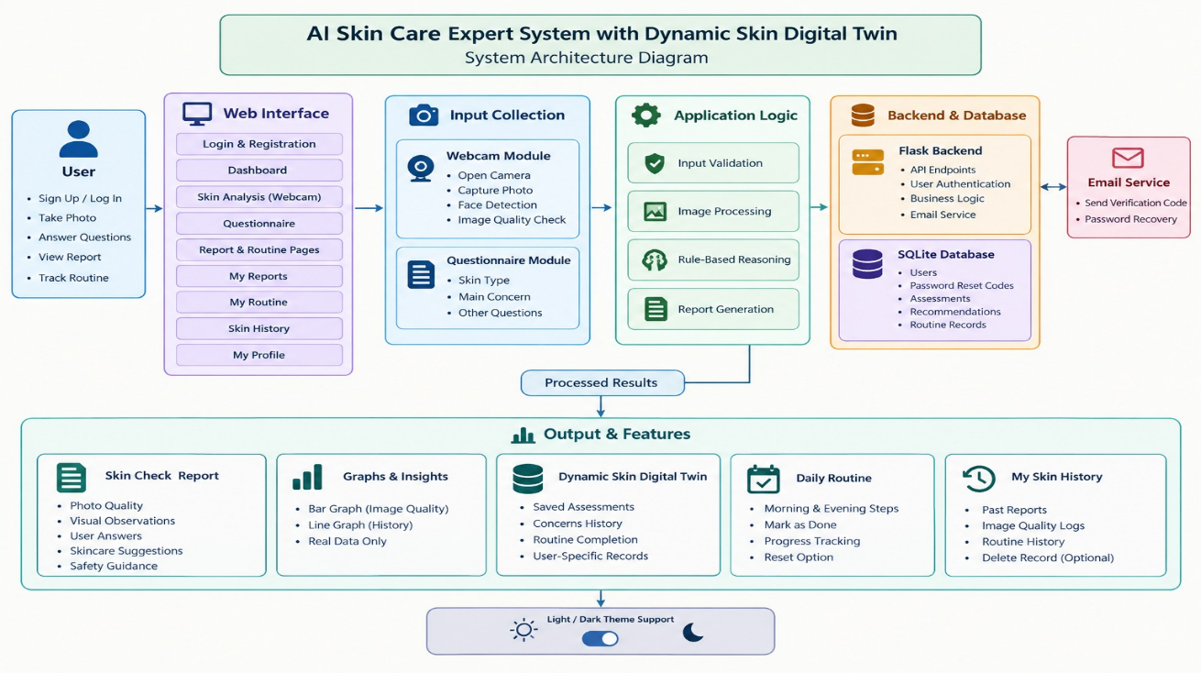
Fig. 3.1 System architecture

The email service connects to the password recovery module to send verification codes.
The webcam image is processed locally where the implementation permits. Personal photos are not stored by default.
3.3 WORKING METHODOLOGY

The system follows these steps:

The user creates an account or logs in.

The dashboard displays the available skincare features.

The user opens the webcam and captures a face image.

The application checks face detection and image quality.

The user answers questions about their skin concerns.

The rule-based engine evaluates the available information.

The application creates a readable assessment report.

The user can view general skincare suggestions and a daily routine.

The user can save or download the report.

The graphs present actual recorded information.

The user can switch between light and dark themes.

3.4 ALGORITHMS AND TECHNIQUES USED
3.4.1 Haar Cascade Face Detection
Haar Cascade is a traditional computer vision method used to detect faces in images. The system processes the captured image and identifies face candidates. Overlapping detections must be consolidated so that one visible face is not incorrectly counted severl times.
3.4.2 IMAGE-QUALITY ANALYSIS
Basic image-processing calculations can estimate properties such as brightness and sharpness.
These measurements help determine whether a photo is suitable for basic visual processing. They do not directly measure skin health.

3.4.3 RULE-BASED REASONING
The system applies predefined rules to available user answers and supported image observations.
Example:
Condition: The user reports that their skin feels dry.
Action: Provide general guidance about gentle cleansing and moisturising.
The recommendation is based on the reported concern rather than an unsupported medical conclusion.

3.4.4 FORWARD CHAINING
If implemented in the rule engine, forward chaining starts with known facts and applies matching rules to derive conclusions.
For example:
* Fact: The user reports irritation.
* Rule: If irritation is reported, suggest a simple routine.
* Conclusion: Display general guidance and appropriate safety advice.

3.5 USER INTERFACE DESIGN

The interface is designed to be professional, simple, and responsive.
The main navigation contains Dashboard, Skin Analysis, My Reports, My Routine, Skin History, and My Profile.

The interface uses:

* Clear buttons and short labels.
* Consistent colours and typography.
* Organised report cards.
* Simple forms and selectable options.
* Helpful error messages.
* Responsive layouts.
* Light and dark themes.

Technical debugging information is kept out of normal user-facing pages.

3.6 SECURITY AND PRIVACY

The system uses secure password hashing, input validation, protected pages, and user-specific database records. Password recovery uses a time-limited verification code sent to the registered email address. The code is verified on the backend and invalidated after successful use.

4. MODULES DESCRIPTION

4.1 MODULE 1: USER AUTHENTICATION
This module manages account registration, login, logout, and password recovery. Users can register with their name, username, email address, and password. The system validates the details and stores the password using secure hashing. During login, the application verifies the credentials against the user database. The forgot-password feature sends a time-limited verification code to the registered email address when email delivery is configured.


4.2 MODULE 2: INTERACTIVE SKIN ANALYSIS
This module stores the stations (name and schematic coordinates), the lines, and the segments between adjacent stations with their distance, fare and running time This module enables users to capture face images and provide information about their skincare concerns. The webcam interface provides Open Camera, Capture Photo, Retake Photo, and Close Camera buttons. The captured image is processed using the implemented face-detection and image-quality techniques. The module handles camera permission problems, blurry images, poor lighting, and face-detection failures.
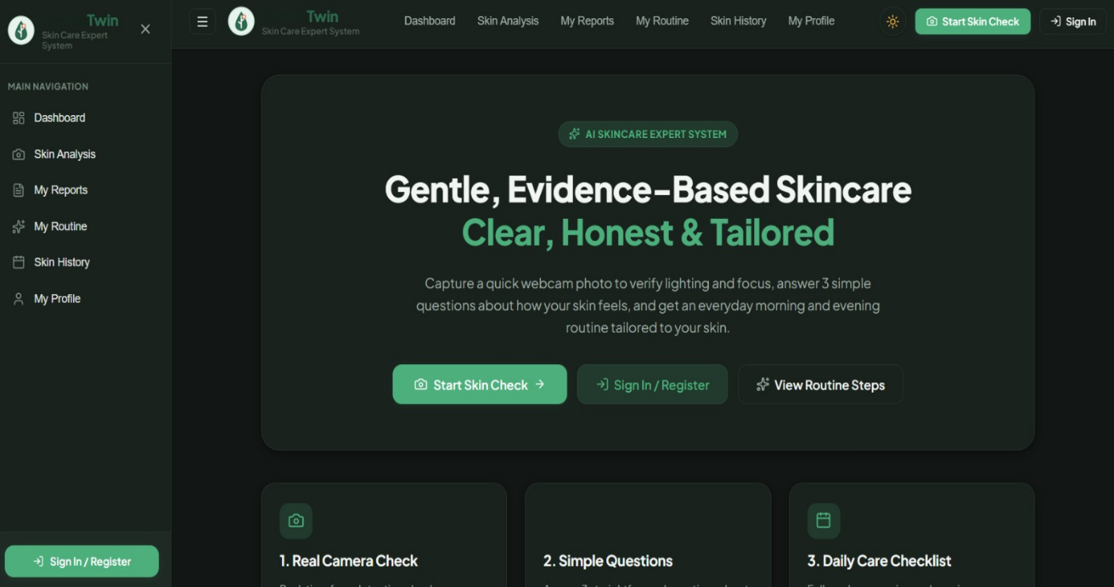

4.3 MODULE 3: SKIN CARE REPORT GENERATION
This module creates a readable report using supported image observations, questionnaire answers, and rule-based recommendations.
The report contains:
* Assessment date.
* Photo-quality results.
* Supported visual observations.
* A summary of user-reported concerns.
* General skincare suggestions.
* Relevant safety guidance.
* Buttons for saving, downloading, and viewing the routine.

The report avoids technical code, raw data, and unsupported medical claims.

4.4 MODULE 4: SKIN DIGITAL TWIN AND HISTORY

This module maintains a digital record of saved assessments and routine activities. It displays assessment dates, user-reported concerns, available image-quality observations, and completed routine steps. The information is stored against the authenticated user's account. The module uses actual saved records and does not create artificial progress.

4.5 MODULE 5: GRAPHICAL INSIGHTS

This module displays useful graphs based on available records.
4.5.1 BAR GRAPH — PHOTO
The bar graph displays supported image-quality measurements, such as brightness and sharpness.
The graph includes readable labels, a suitable scale, and tooltips where supported. The measurements describe the photo and must not be presented as a skin-health score.
4.5.2 LINE GRAPH — ASSESSMENT HISTORY
The line graph displays a suitable historical metric, such as a supported image-quality measurement across assessment dates or assessment activity over time. It uses actual saved records. If sufficient data is unavailable, the application displays a helpful message rather than a fabricated graph.
4.6 MODULE 6: DAILY SKINCARE ROUTINE
This module provides simple morning and evening skincare steps.

The morning routine may include gentle cleansing, moisturising, and broad-spectrum SPF 30+ sunscreen. The evening routine may include gentle cleansing and moisturising. Users can mark each step as completed. The application stores completion records against the correct user and date and updates the progress display. Recommendations remain general and do not promise a cure or a guaranteed recovery date.

4.7 MODULE 7: THEME AND INTERFACE MANAGEMENT
This module allows users to switch between light and dark themes.
A sun or moon icon provides a simple theme control. The selected theme updates the page backgrounds, text, cards, forms, navigation, and graphs.
The preference is remembered using local storage or another suitable settings mechanism. The interface is designed to remain readable and accessible in both themes.

5. IMPLEMENTATION AND RESULTS

5.1 EXPERIMENTAL SETUP
The following table should be updated to match the technologies actually used in the final implementation.
COMPONENTS | TECHNOLOGY
Frontend | React, if used
Styling | CSS
Webcam access | Browser Media Device
Face detection | OpenCV Haar Cascade
Backend | Flask, if used
Database | SQLite, if used
Rule engine | Python
Graphs | Recharts or chart lib
Email delivery | Configured SMTP
Version control | Git, if used

The application should be tested in a supported browser on a device with camera access. Camera access normally requires HTTPS or localhost.
5.2 USER INTERFACE IMPLEMENTATION
The frontend contains the dashboard, authentication pages, skin analysis page, report page, daily routine page, assessment history, and profile settings.
The design uses simple navigation, interactive buttons, responsive cards, and clear messages.
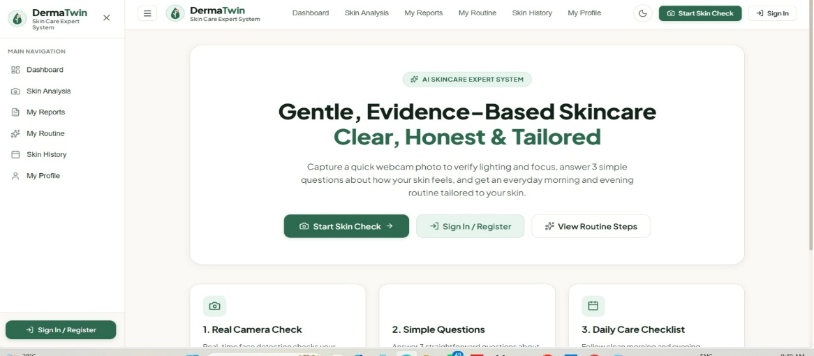
5.3 WEBCAM AND SKIN ANALYSIS IMPLEMENTATION
The webcam module requests permission and displays the actual camera stream. After capture, the user can preview the photo and retake it before analysis. The image-processing module performs the implemented face-detection and photo-quality checks. The application then evaluates the questionnaire answers using the rule-based engine. 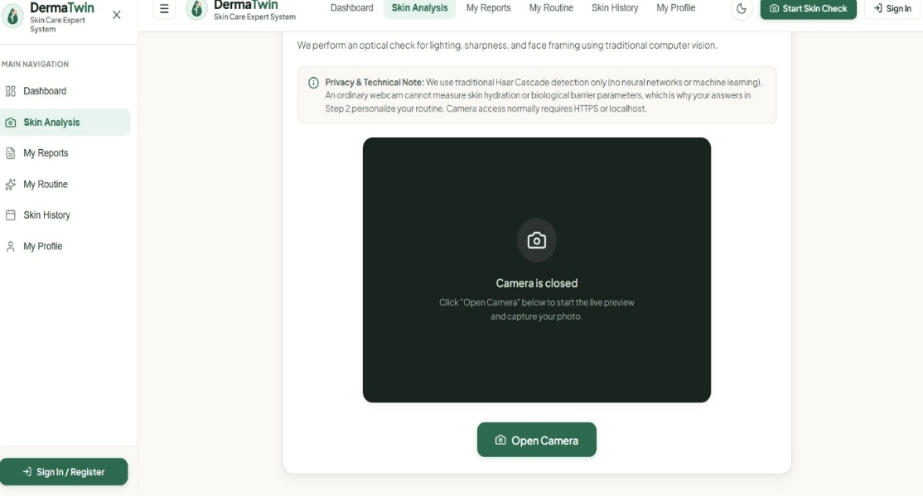
5.4 GRAPHICAL INSIGHTS IMPLEMENTATION
The graphical insights page contains a bar graph and a line graph. The bar graph represents supported image-quality measurements. The line graph represents an appropriate metric from actual saved assessment history. The graphs include readable titles, axis labels, and suitable empty states. The application does not invent data to populate a chart.
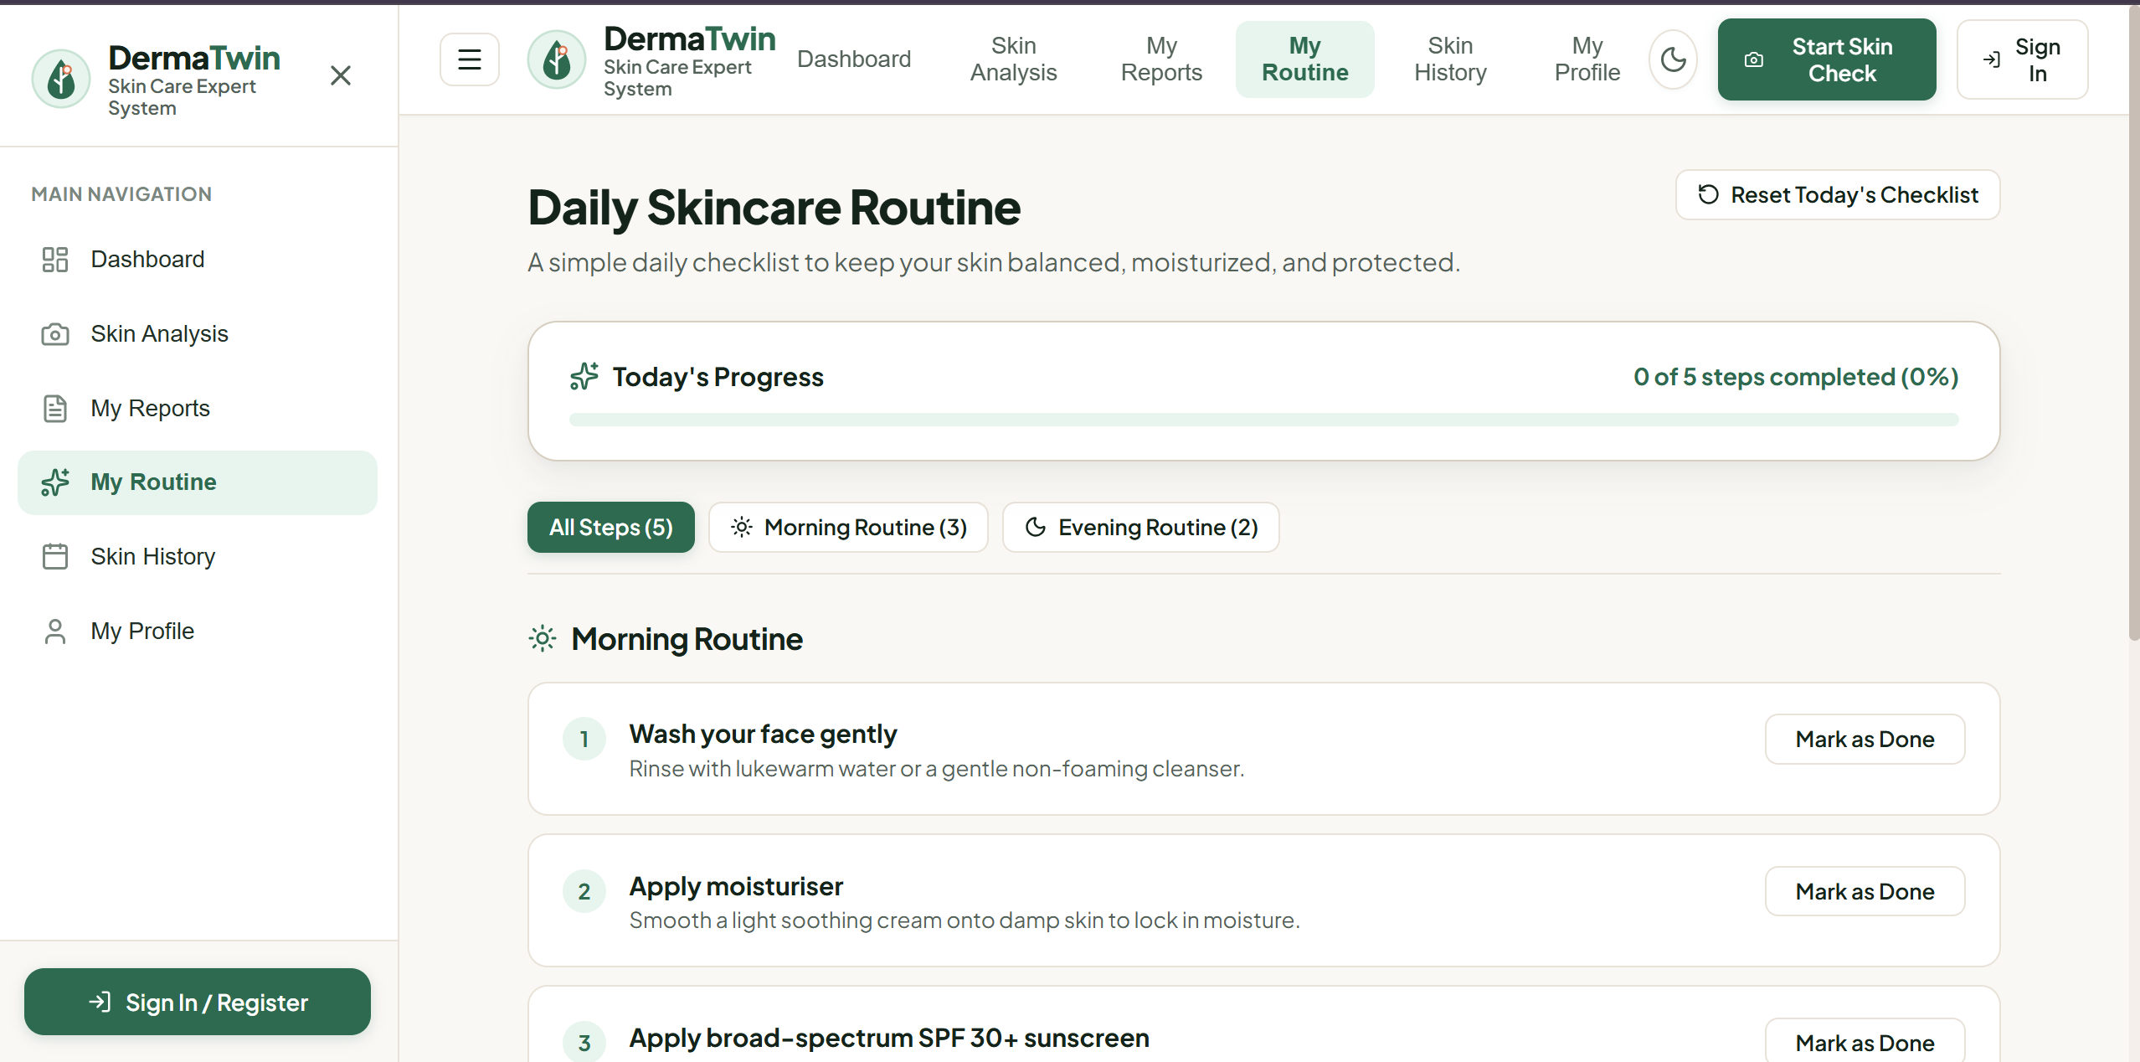
5.5 AUTHENTICATION AND PASSWORD RECOVERY
The authentication module supports account registration, login, logout, and protected pages. Password recovery uses a verification code sent to the registered email address. The code has an expiry time and is invalidated after successful use.
5.6 RESULTS AND DISCUSSION
The system should be evaluated based on the successful completion of the authentication, camera capture, image-quality checking, report generation, graph display, and history workflows. The final results section should explain which features were tested successfully, which required additional configuration, and what limitations were observed during testing.
The system should not claim medical accuracy or improved skin health based solely on image-quality measurements or user-reported answers.

6. CONCLUSION AND FUTURE WORK
6.1CONCLUSION
The AI Skin Care Expert System with Dynamic Skin Digital Twin is designed to make basic skincare guidance easier to access through a professional and interactive web application. The application combines traditional computer vision, user-provided information, and rule-based reasoning to provide understandable suggestions. Its webcam interface supports photo capture and basic image-quality checking, while its report page presents relevant information in a clear and organised format. The system also includes account management, email-based password recovery, light and dark themes, graphical insights, a daily skincare checklist, and a digital history of saved assessments. The project demonstrates how traditional image processing and rule-based reasoning can be combined with a user-friendly web interface without using machine learning or deep learning. It is intended for general skincare education and does not replace professional medical advice.
6.2 FUTURE WORK

Future improvements may include:

1. Adding support for additional languages.
2. Improving accessibility for users with different needs.
3. Enhancing historical comparison and report management.
4. Adding optional browser or email reminders.
5. Improving camera compatibility across devices.
6. Introducing additional validated image-quality checks.
7. Reviewing skincare guidance with qualified healthcare professionals.
8. Expanding privacy settings and user-controlled data deletion.
9. Conducting usability testing with a larger group of users.

7. REFERENCES

1. Bradski, G. (2000). “The OpenCV Library.” *Dr. Dobb’s Journal of Software Tools*.

2. Gonzalez, R. C., and Woods, R. E. (2018). *Digital Image Processing*, 4th Edition. Pearson.

3. MDN Web Docs. “Media Devices: get User Media ().” https://developer.mozilla.org/en- US/docs/Web/API/MediaDevices/getUserMedia

4. OpenCV. *OpenCV Documentation*. https://docs.opencv.org/

5. Russell, S., and Norvig, P. (2021). *Artificial Intelligence: A Modern Approach*, 4th Edition. Pearson.

6. Viola, P., and Jones, M. (2001). “Rapid Object Detection Using a Boosted Cascade of Simple Features.” *Proceedings of the IEEE Conference on Computer Vision and Pattern Recognition*.

7. World Wide Web Consortium (W3C). *Media Capture and Streams*. https://www.w3.org/TR/mediacapture-streams/

